Generalized Lotka–Volterra equation:

* The generalized Lotka–Volterra equations are a set of equations which are more general than either the competitive or predator–prey examples of Lotka–Volterra types.
* They can be used to model direct competition and trophic relationships between an arbitrary number of species.
* Useful as a theoretical tool for modeling food webs.
* However, they lack features of other ecological models such as predator preference and nonlinear functional responses, and they cannot be used to model mutualism without allowing indefinite population growth.

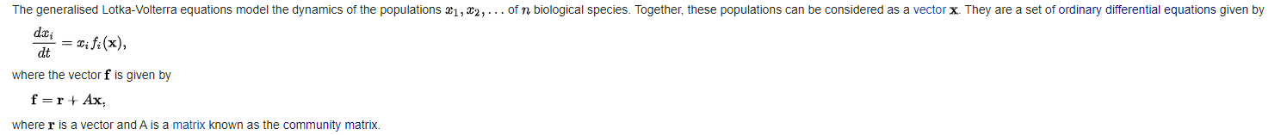

* The values of r are the intrinsic birth or death rates of the species. A positive value for ri means that species i is able to reproduce in the absence of any other species (for instance, because it is a plant), whereas a negative value means that its population will decline unless the appropriate other species are present (e.g. a herbivore that cannot survive without plants to eat, or a predator that cannot persist without its prey).
* The values of the matrix A represent the relationships between the species. The value of aij represents the effect that species j has upon species i. The effect is proportional to the populations of both species, as well as to the value of aij. Thus, if both aij and aji are negative then the two species are said to be in direct competition with one another, since they each have a direct negative effect on the other's population. If aij is positive but aji is negative then species i is considered to be a predator (or parasite) on species j, since i's population grows at j's expense.
* The diagonal terms aii are usually taken to be negative (i.e. species i's population has a negative effect on itself). This self-limitation prevents populations from growing indefinitely.

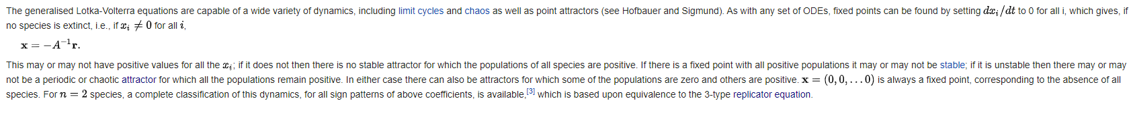

* A credible, simple alternative to the Lotka-Volterra predator–prey model and their common prey dependent generalizations is the ratio dependent or Arditi-Ginzburg model.